- 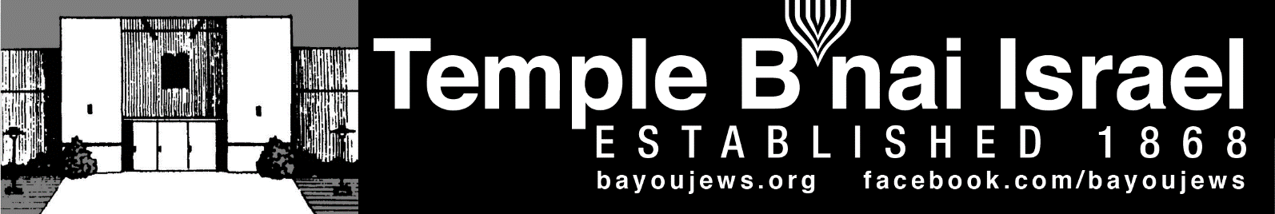

January 2024
Tevet 20, 5784 – Shevat 21, 5784
______________________________________________________________________________
______________________________________________________________________________

Rabbi Judy’s Message
Another year has begun. Welcome 2024! I do hope this year brings our world peace and more kindness. I hope it brings our congregation good health and a compassionate community willing to support our Temple and the people in it. We need to be there for each other more than ever.
As we approach this New Year, please remember to keep the Temple informed about what is going on with you and your family. If you need prayers for healing, call Shirley to add a name to our Misheberach list. If you want a call or visit from me, please let me know. If you have a simcha (joyous event), let us know about that so we can rejoice with you. And, remember if you want to make a donation to a Jewish cause, our Temple is a great place to do that. We are always in need of things to keep our Temple running and it will continue to exist and be vibrant because of your help and generosity.
When I am there in January, we will welcome some new Jews into our community. They have been studying with me toward conversion for almost a year – some even longer. So, on Friday, January 5 at the Temple we will publically welcome them into our Jewish community. This decision to join the Jewish people is not to be taken lightly, especially now when there is so much hate in our world. It is a big decision and a big commitment. I hope you will be there to show your support as they become members of “the Jewish tribe.” Our congregation will host a nice oneg after the service and conversion ceremony.

Rabbi Judy’s Message Continued
Those who will join our Jewish community are:
Lucas Byrd – Emet Lev Keshet mibeit Avraham v’Sarah
Kara Carter – Chaya Hadassah mibeit Avraham v’Sarah
Jennifer Dingus – Shalviya Chana bat Avraham v’Sarah
Rocky Hemphill – Tzuriel Moshe ben Avraham v’Sarah
Katherine Hillman – Aviva Shulamit bat Avraham v’Sarah
Cecil Newton – Yitzchak mibeit Avraham v’Sarah
After this service with you, I will be leaving for a nice vacation on Kauai (Hawaii) with Bob. I am fortunate to be able to lead services for the Jewish Community of Kauai on Saturday, January 20 while I am there. It is always an honor and a privilege to be asked to lead services and I am looking forward to this special Shabbat. Stay safe, healthy and warm.
Rabbi Judy

~~~~~~~~~~~~~~~~~~~~~~~~~~~~~~~~~~~~~~~~~~~~~~~~~~~~~~~~~~~~~

SERVICE SCHEDULE

January 5th Rabbi Judy (Conversion Class)
January 12th Mike Rhymes
January 19th Don Smith
January 26th Deb Roa

Services will be held in person at the Temple, as well as live streamed through our website, www.bayoujews.org, unless otherwise noted.

Lay leaders are subject to change.

~~~~~~~~~~~~~~~~~~~~~~~~~~~~~~~~~~~~~~~~~~~~~~~~~~~~~~~~~~~~~
~~~~~~~~~~~~~~~~~~~~~~~~~~~~~~~~~~~~~~~~~~~~~~~~~~~~~~~~~~~~~

PRESIDENT’S MESSAGE

It was great to see so many at the Chanukah party. It is always special when all the candles on the menorahs are lit. I also want to thank everyone that helped make the latkes.

We are starting the New Year by welcoming new converts into the Jewish faith on Friday, January 5 during our regular Shabbat service. There will be a special oneg following the service. Please bring an hors d’oeuvre to share.

I hope 2024 finds everyone healthy and is filled with joy and happiness,

Deb Roa, President

~~~~~~~~~~~~~~~~~~~~~~~~~~~~~~~~~~~~~~~~~~~~~~~~~~~~~~~~~~~~~

CONGRATULATIONS

HAPPY ANNIVERSARY

Peggy & James Greenbaum January 29th 69 years

HAPPY BIRTHDAY

Jade Jefferson – January 12th (7yrs) Cecile Smith – January 20th
Nancy Shlosman – December 8th Nanette Cohen – December 10th
Phyllis Marcus – January 22th Carly Laudenheimer – January 22th (9 Yrs)
Michal Hakim – January 26th Ron Israel – January 27th

~~~~~~~~~~~~~~~~~~~~~~~~~~~~~~~~~~~~~~~~~~~~~~~~~~~~~~~~~~~~~

YAHRZEIT

JANUARY 5TH
Esther B. Masur Wilma Zavelo Marx
Dora Israel Hettie Lowentritt
Tola Rosenberg 5-19 Bessye L. Stern
Sol Rosenberg 5-20 Sol Arthur Stern
Carl Aron

JANUARY 12TH
Ralph Marks Herman Masur 1-11
Abe Froug 1-7 Sam Smith
Doniel Weil Lillian Heninger
PhilipWilenzick Louis Flemin
Dula Mae Roby Carl Goettinger
Maurice A. Roby Yetta Leibowitz
Rachel Rosenberg

JANUARY 19TH
Marvin Carlie Louise Hakim 6-2
Leopold Hirsch Maude Selig 2-7
Joan Halperin 5-15 Louis Masur
David Masur 1-5 Morris B. Rosen
San Rubin, Sr. Stanley Shlosman
David Masur Joe Doernberg
Jan Fishman Clem Heninger
Stella Heninger

JANUARY 26TH
Moise King Dr, Fred Marx
Jakob Strauss Lenore Scwelling
Dora Heiman Dr, Samuel Lewis
Virgina Marx Sam Zavelo 1-8
Alan Blumenthal 2-6 Leonard Lemle 3-7
Minnie Kristal Levine Louis Weinberg
Carol Marx Tootsie Sarah Scherck 3-15
Etta Levine

Yahrzeit continued

JANUARY 31ST

Ida Scheck Bogen 3-19 Edgar Masur 1-4
Abraham Blumenthal 2-5 Sam Adler
Paul Aron Cole Richardson

The numbers following a name is the location of their plaque on the Memorial Board in the Foyer. The first number represents the column. The second number represents the position in the column. The lights on both sides of the plaque are light during the week of their Yahrzeit. If you would like to have your loved one remembered with a bronze plaque on the memorial board, order forms are available at the Temple.

~~~~~~~~~~~~~~~~~~~~~~~~~~~~~~~~~~~~~~~~~~~~~~~~~~~~~~~~~~~~~

RITUAL AND WORSHIP

I want to thank those who led services in December

The start of this New Year brings 6 new converts who will have their official welcome to the Jewish faith at the Shabbat service on January 5. We will have a special oneg following the service.

January is also Tu B’Shevat, the ‘new year” for trees. We mark Tu B’Shevat by eating fruit, particularly the kinds that are singled out by the Torah in its bounty of the Holy Land: grapes, figs, pomegranates, olives, and dates.

Mike Rhymes, Chair

~~~~~~~~~~~~~~~~~~~~~~~~~~~~~~~~~~~~~~~~~~~~~~~~~~~~~~~~~~~~~

~~~~~~~~~~~~~~~~~~~~~~~~~~~~~~~~~~~~~~~~~~~~~~~~~~~~~~~~~~~~~

DONATIONS

In Memory of Yvonne Stephen

Phillip Roby

In memory of Sam Davidson

Mike Rhymes

In memory of Steve Blate

Don & Judy Marx

~~~~~~~~~~~~~~~~~~~~~~~~~~~~~~~~~~~~~~~~~~~~~~~~~~~~~~~~~~~~~

WANT TO KNOW MORE ABOUT JUDAISM?
Rabbi Judy will be offering another Introduction to Judaism class on Saturday, February 10 from 1-4 pm at the Temple in the Social Hall. This is a class that is open to anyone who wants to learn more about what Jews believe, our holidays, customs, worship, history, etc. The class will end with an Ask the Rabbi session and will include a tour of the sanctuary and Precious Legacy Museum. It is free and open to the public, however, reservations are required. Please share this information with anyone you feel might want to attend. Reservations can be made by emailing or calling the temple at 1868temple@gmail.com or 318 387-0730.
~~~~~~~~~~~~~~~~~~~~~~~~~~~~~~~~~~~~~~~~~~~~~~~~~~~~~~~~~~~~~
~~~~~~~~~~~~~~~~~~~~~~~~~~~~~~~~~~~~~~~~~~~~~~~~~~~~~~~~~~~~~
DO YOU WANT TO LEARN HEBREW?
Several congregants have mentioned to me that they would love to learn to read Hebrew and learn more about what the prayers mean. So here is your opportunity - A colleague of mine who is a congregational Rabbi in Florida will be starting an online Hebrew class soon. This is a great opportunity for you to learn and I would highly recommend it. If you have an issue with the cost, Rabbi Fanwick can definitely work something out with you. Here is the information:
Hebrew 101: The Basics of Biblical Hebrew for Adults
Rabbi Karen Fanwick, Temple Israel of Brevard, Melbourne, FL

This course is designed for adults who have struggled to learn Hebrew, never had the opportunity to learn Hebrew or are new to Judaism and wish to learn the language of our people.

You will learn the Alef-Bet, the Jewish alphabet, along with all of the different vowel representations and sounds. At first it will sound like gibberish, but you will be reading real words by the end, including a couple of basic prayers.

The cost of the course is $180 and will include a text book plus on-line instruction. There will be access to instructional videos to enhance your learning and retention. The course generally runs about 10 weeks. The next course will begin the end of February or the first of March with time and day of the week to be determined.

If you are interested in such a course, please contact Rabbi Karen Fanwick at
rabbikaren630@gmail.com

~~~~~~~~~~~~~~~~~~~~~~~~~~~~~~~~~~~~~~~~~~~~~~~~~~~~~~~~~~~~~

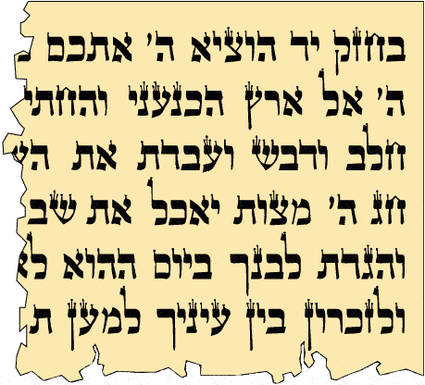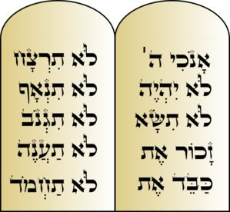
Chanukah Party Fun

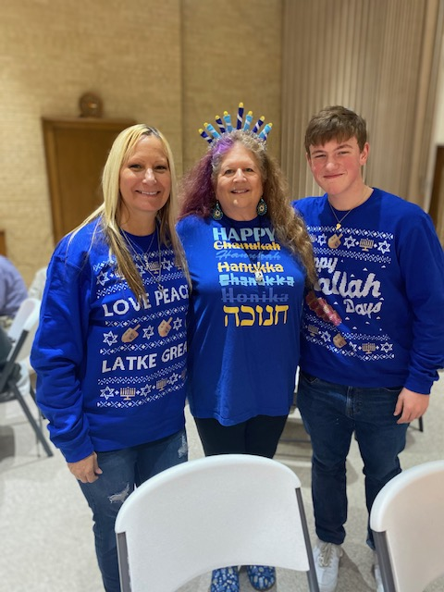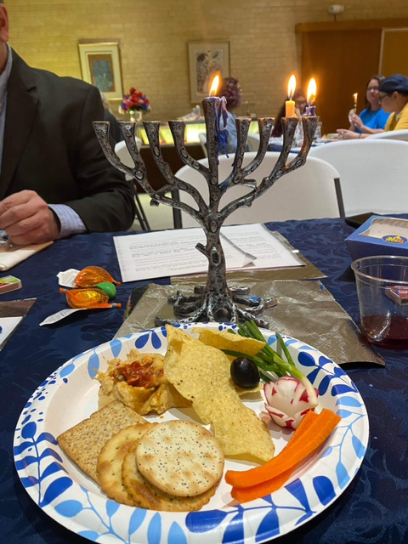
Allison Dalton, Rabbi Judy, Jack Johnson Light of the menorah

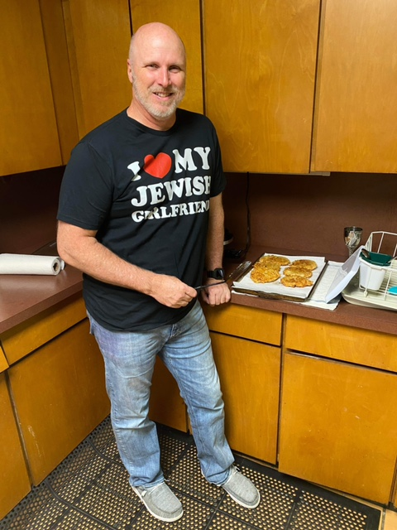 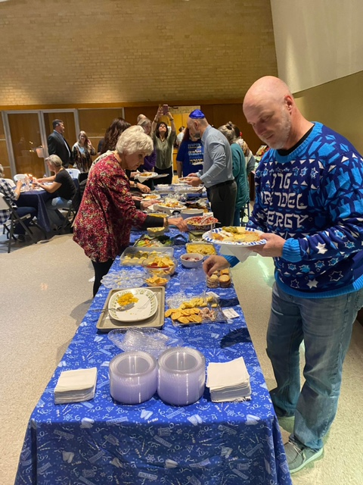 Brian White making latkes Lots of Food for Everyone

